**Team members**

* **محمد ثابت حسين ثابت**
* **مايكل محسن شكري حنين**
* **ماريو ايمن مفيد**
* **محمد أسامه مختار أحمد**

**Project number (71)**

**Section (3) Group (2).**

***1-Project charter***

***Project system :* Application for restaurant**

***Project sponsor* : Edita , orange , xiaomi.**

***Project manger:* Yasser Mohamed**

***Project team :* Mario Ayman ,Michael Mohsen , Mohamed Osama,**

**Mohamed Thabet.**

1. ***Project purpose :***

* **all restaurant will upgraded to this application by next year and will make ordering orders more easy in large places like food courts.**

1. ***Business case:***

* **pen and paper and calculator have served this restaurant since 1980 However, it’s time to let it go. We’ll be embracing a new application to do the work of waiter but easily and without mistakes.**
* **Our application will make it easier to order orders without any problem and without any mistakes**
* **Increase the income for the restaurant as it will save time of delay waiting waiter and any mistake happen will order orders in busy times**
* **Application will be a big deal with restaurant owners will by the time we will reduce workforce of waiters**
* **By time our application will be the main application and system in every restaurant and food courts and cafe by the time**

1. ***Project results***

* **Application in every restaurant and food courts**
* **easy to reach the customers**
* **All implementation complete by April 22**

1. ***Project resources***

* **Budget : $150,000**
* **Test lab reserved for 4 month duration**
* **Consult on of web developers**

1. ***Project Constraints, Assumptions, and Risks***

* **Project must be completed by 22 April 2022**
* **project must not exceed $200,000**
* **Our preferred vendors should be able to deliver our new workstations and servers on time without affecting the project schedule**
* **Difficult to use at first**

1. ***Basic Milestone Timeline***

* **January: make a whole view for program and its design to developers and start on its design**
* **February: finish its design and its front end**
* **March : finish the application and make a beta version from it and wait for feedbacks**
* **April : receive the feedback on the application, and fix the problems if exist and launch the program and be ready to use**

***2-Project scope statement***

1. **Scope description:**

* **A profitable application**
* **It’s easy by all age group**
* **When you connect to this app. It will help your Restaurant to display everything you have to make customers use it easily**

1. ***Acceptance criteria:***

* **The application is easy to use**
* **The application save a lot of time and money as it speed up the kitchen work and the whole service**
* **It tell the user the accurate cost of his orders**
* **You can use this app while in home to reserve what you want before going to the restaurant to save time such that once you arrive the restaurant you pick what you want**

1. ***Deliverables:***

* **Displays the menu of most nearby coffee shops**
* **You can order what you want from home**
* **It help the restaurant owner to organize his restaurant**

1. ***Exclusion*:**

* **Payment by application**
* **The application limits are in the user’s city not in the other cities**

1. ***Constraints*:**

* **Budget** : **$150,000**
* **Time: four months**
* **Resources: test lab reserved for two months**

1. ***Assumptions*:**

* **Most restaurants would approve to our application**
* **Cost accuracy**

***3-Work Breakdown Structure***

**Application for Restaurant**

**1.4**

**Executing and controlling**

**1.5**

**Closing**

**1.3**

**Create the application**

**1.1**

**Initiating**

**1.2**

**Planning**

**sss**

**j**

**1.5.1**

**Conduct closeout meetings**

**1.5.2**

**Create project closeout documentation**

**1.4.1**

**Launch the application**

**1.4.2**

**Market the application**

**1.4.3**

**Get feedback from users**

**1.4.4**

**Improve the application**

**1.3.1**

**Software design**

**1.3.2**

**Building a software model**

**1.3.3**

**Constructing code**

**1.3.4**

**Testing**

**1.3.5**

**Design user interface**

**1.1.1**

**Appoint the project manager and project team**

**1.1.2**

**Create the project charter**

**1.2.1**

**Scope management plan**

**1.2.2**

**Cost management plan**

**1.2.3**

**Risk management plan**

**1.2.4**

**Schedule management plan**

***4- WBS Dictionary***

**1.1 initiating**

* **1.1.1 Appointing the project manager and the project team: The first person appointed to the project is typically the project manager. The reason is that the project manager is responsible for ensuring that the right candidates with the right skills are appointed into the right roles within the project. The project manager will appoint his team leaders first and the team leaders will in turn appoint the team members. He will appoint software development team leader, marketing team leader, UI designing team leader, testing team leader, and network engineering team leader.**
* **1.1.2 Creating the project charter: the project charter authorizes the project and it defines the business need in full. It identifies the sponsor of the project and the project manager. It makes the project manager accountable for the project and it assigns authority to the project manager on behalf of the project sponsor. The project manager creates the project charter and it should be created in the initiation phase.**

**1.2 Planning**

* **1.2.1 Creating the scope management plan: The scope management plan is the collection of processes that are used to ensure that the project includes all the tasks required to complete the project while excluding all the work/tasks that are out of scope. The primary purpose of the scope management plan is to define how the project scope will be explained, developed/structured, and verified.**
* **1.2.2 Creating the cost management plan: A cost management plan is a document that helps you map and control a budget. It enables project managers to estimate their costs, allocate resources to the right areas, and control overall spending. Cost management plans keep all project costs in one place, including direct and indirect costs. A project manager will track these costs to ensure there are no budget overruns. It is one of the most essential parts of a project’s planning phase that helps to complete the project on time and on budget.**
* **1.2.3 Creating the risk management plan: risk management plan is a document that a project manager prepares to foresee risks, estimate impacts, and define responses to risks and it’s designed to eliminate or minimize the impact of the risk events that have a negative impact on the project.**
* **1.2.4 Creating the schedule management plan: A schedule management plan is the precise organization of project activities and tasks by time factors. It outlines the start and end dates of tasks and milestones that must be accomplished for project completion.**

1.3 **create the application**

* 1**.3.1 The software developer will design the application. Software design usually involves problem-solving and planning a software solution**
* **1.3.2 The software developer will build a model of the software with a modeling tool that uses a modeling language to conduct early validation, prototyping and simulation of the design.**
* **1.3.3 The software developer will construct the code in the appropriate programming language. This process involves team review to eliminate problems early and produce quality software faster.**
* **1.3.4 The software tester will test the software to check whether the actual software product matches expected requirements and to ensure that software product is free from errors.**
* **1.3.5 Design user interface: The UI designer will design the user interface. The user interface (UI) is the point at which human users interact with a computer, website or application. The goal of effective UI is to make the user's experience easy, requiring minimum effort from the user to receive maximum desired outcome.**

1. 4 **Executing and controlling**

* **1.4.1 Launch the application: The network engineer will launch the application and the project manager will approve it. it's important to be available across multiple platforms to reach the largest number of users.**
* **1.4.2 Market the application: The marketing team will market the application. One of the best ways of marketing is social media. Social media marketing is a powerful way for businesses of all sizes to reach customers.**
* **1.4.3 Get feedback from users : It’s so important to get feedback from users. It allows us to determine which of our proposed features are most important to them in the context of our app**
* **1.4.4 improve the application : Once we’re armed with this knowledge, we can begin to prioritize our roadmap based on what will add the most customer delight. we’ll also be able to determine which of our current features needs a little touch-up to meet or exceed customer expectations.**

1.5 **Closing**

**• 1.5.1 Conducting closeout meetings: In These meetings team evaluates project successes by looking at planned and actual deliverables, comparing achievements with the project’s objective. Team also identifies areas for improvement, lessons learned and recommendations for future projects.**

**•1.5.2 Project closeout report: The purpose of this report is to mark the completion of the project by assessing the project's performance, identifying the lessons learned. The report should capture what went well, what were the challenges, recommended future actions, and**

**5-Roles and Responsibilities Matrix**

|  |  |  |  |  |  |  |  |  |
| --- | --- | --- | --- | --- | --- | --- | --- | --- |
| Name .  . tasks | Project manager | Project sponsor | Application  Developer | ZenWorks  Expert | Technical architect | Designer | Network  Engineer | Financial Expert |
| Create the project | **A** | **R** | **C** |  | **P** | **P** | **P** | **R** |
| Do a feasibility study for the project | **A** | **R** |  |  |  |  |  | **C** |
| Program design |  |  | **R** |  | **R** | **C** |  |  |
| Test the project system | **R** | **R** | **P** | **C** | **P** | **P** | **P** |  |
| Choose a staff  For the project | **A** | **P** |  |  |  |  |  | **R** |
| Install the application on devices | **R** |  |  | **C** | **C** |  |  |  |

**A = Approves P = Participant**

**R = Reviews C = Creator**

**6-Project Network**

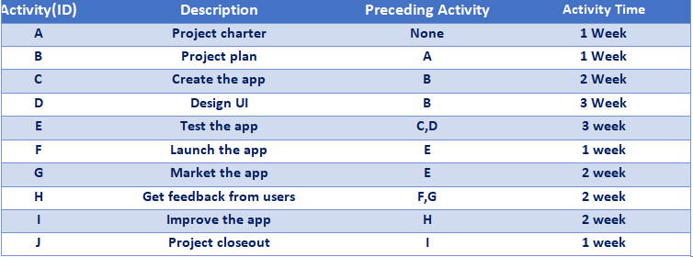

* **Automated Warehouse Network**

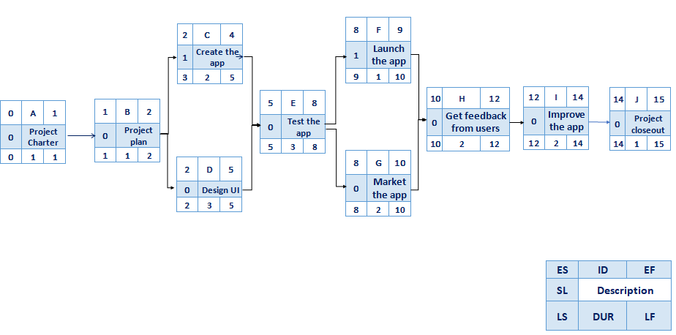

**7-Resource constrained project**

* **Resource constrained Schedule**

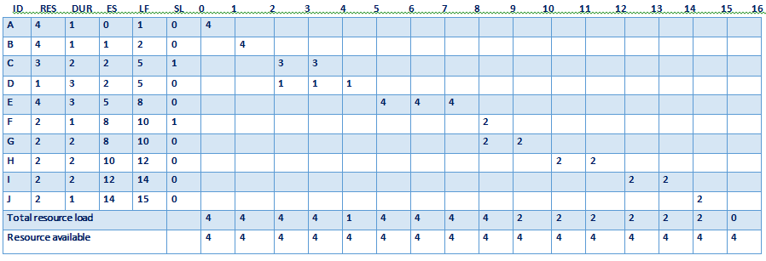

**8-Time-Phased Budget Baseline**

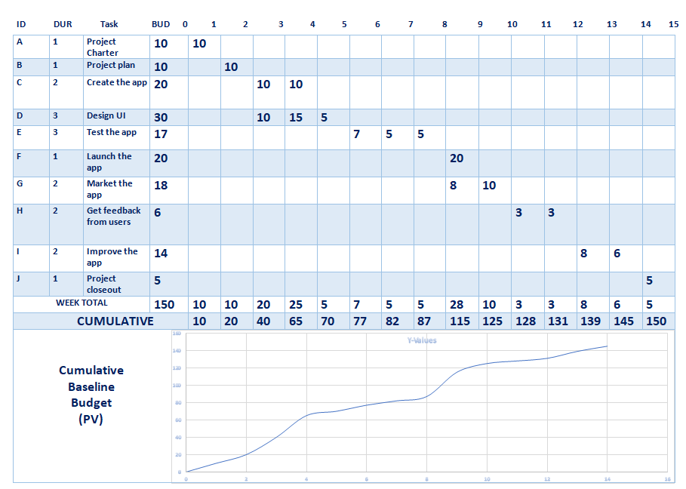

**9- Risking Management and Monitoring**

**1-Risks**

* **Risk of security breaches**
* **Risk of project to produce results that are inconsistent with the project specification**
* **Error in cost estimation commonly**
* **Risk of unplanned scheduling conflicts like events cause the project to be delayed**
* **Any error in the software or in the server could affect efficiency of the project**
* **Difficult to use at first**

**2-Monitoring**

* **Schedule and cost control where there are monitored closely**
* **Measure each details in the project**
* **Stay informed with feedbacks after release the application**
* **Keep in touch with the restaurant and food courts which buy the application to know if they face any problem with the application**